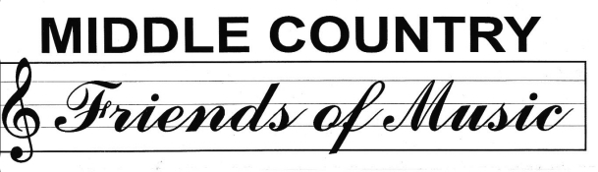

Lettice Washington – *President*

*Sue Lasher- Vice President*

*Martina Toback– Treasurer*

*Debbie Brown-Secretary*

*Dr. Diana Cook – Director of Music, Fine Arts & Community Media Relations*

The Middle Country Friends of Music was founded in 1981. Our board is made up of volunteers who work in conjunction with the Music Department to promote the talents of our children. The Friends of Music co-sponsor the annual POPS concert along with other fund-raising ventures which allow us to offer our music students the following:

**- Elementary Schools**- Student of the Trimester Awards, 5th grade All District Concert

T-Shirts to over 300 participants

**- Middle Schools**- Six 8th grade Friends of Music monetary awards (2 for each ensemble at each middle school) & an annual T-Shirt design contest prize

**- High Schools**- 18 monetary scholarships (3 in each ensemble at each high school)

Additionally, the Friends of Music awards $3000 in Mini Grants to teachers who apply for program enhancement & student enrichment. We also advocate for the preservation of music & music related programs in our district. Contact us at [middlecountryfriendsofmusic@gmail.com](mailto:middlecountryfriendsofmusic@gmail.com) & please “like” us on ***Facebook,*** & follow us on ***Twitter:* @MCCSD_Music**& on ***Instagram:* @mccsd_music_**

**OVER 30 YEARS SUPPORTING MUSIC IN THE MIDDLE COUNTRY COMMUNITY!**

**___________________________________________________________________________**

**MIDDLE COUNTRY FRIENDS OF MUSIC 2023-2024 MEMBERSHIP FORM**

DATE________________ **$5.00 PER FAMILY CASH__________ CHECK________**

**MAKE CHECKS PAYABLE TO: MCCSD FRIENDS OF MUSIC**

SUBMIT TO MUSIC TEACHER OR MAIL FORM TO: PO BOX 237 CENTEREACH NY 11720

NEW MEMBER________ RENEWAL MEMBERSHIP______________

Parent First/Last Name**______________________________** Phone#_________________________

Email address: **______________________________________________________________________**

Address**: __________________________________________________________________________**

First/Last Name of Child Band Orchestra Chorus School Grade

**_________________________________ _______ ________ ______ _________ _______**

**_________________________________ _______ ________ ______ _________ _______**

**_________________________________ _______ ________ ______ _________ _______**

**Name and Best contact info for Volunteering**

**________________________________________________________________**